CREATE JAVA APPLICATION

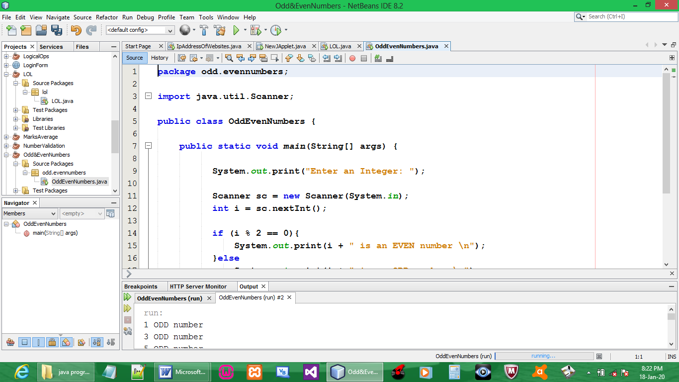

CODE:

package odd.evennumbers;

import java.util.Scanner;

public class OddEvenNumbers {

public static void main(String[] args) {

System.out.print("Enter an Integer: ");

Scanner sc = new Scanner(System.in);
int i = sc.nextInt();

if (i % 2 == 0){
System.out.print(i + " is an EVEN number \n");
}else
System.out.print(i + " is an ODD number \n");
}
}

OUTPUT:

